**Cole:**

* Was not able to do much this last week besides some ui additions and tweaks. Have not been able to figure out the add table button at the current location.

**Anton:**

* Got table information from table fill-out form to load into database
* Made a new, nicer table form view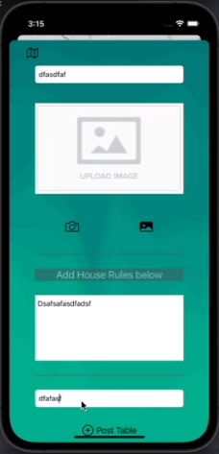

**Ryan:**

* Added ability to pull all documents from a collection, which was added on top of by Kenny and Steve to add the list of tables and makers on map

**Kenny:**

* Added some code to load in table database info and create markers on the map for tables when the app starts

**Steve:**

* Added a table button to the UI which opens a display of all tables from the database